Assignment
Tableau for Business Decisions
Important notes:
- Please document the step by step process you follow and the challenges you face at each step of the process. This is worth 50% of the assignment.
- If at the start you need data in a different format than what Tableau could process, then please indicate what was required. You can use Alteryx or SQL to generate the starting file.
Exploratory Visualization steps
You may want to create different worksheets in Tableau to answer the questions below. Note that we use the same questions asked for the Alteryx :
- Sort the number of rides per day to figure out the top 3 days of the month.
- For the month, which Starting point Station has the most rides being originated?
- For the month, provide the top 10 Starting point Stations (you can do the same for End Stations). Can you map them?
- Which day of the week (Monday to Sunday) has the most rides?
- Which day of the week (Monday to Sunday) has the least rides?
- Characterize the data: how many rides in total, average time per ride, % member rides,…
- Provide the number of rides per day (day of the month 1-30)
- Please provide the names of the top 10 Starting Point Stations
- How many bike rides originate and end at the same station? Are there any patterns?
- On a daily basis, which stations are net-gainers (more bikes in than bikes out) and which stations are net-losers (more bikes out than bikes in)
- Add your own metrics 😊 (what aggregates could you think of? – I have a list if you are interested).
Creating a Dashboard
- This will be decided on upon quick completion of the Exploratory Visualization exercise
Data Structure
All files are available in .csv
Monthly Bike Riding
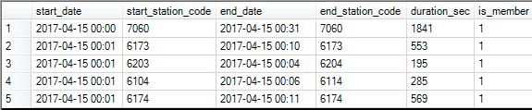
is_member is 0 or 1 (no or yes)
number of monthly files 8 with below # of records

